

COMPUTER network

Lab 11



July 19, 2023

M. Muntazer Mehdi

F200290

Computer Network Lab:

**Task 1:**

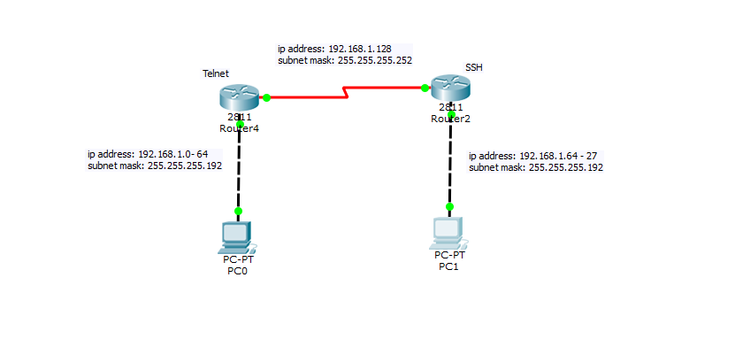

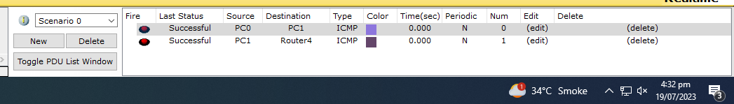

**Router 1:**



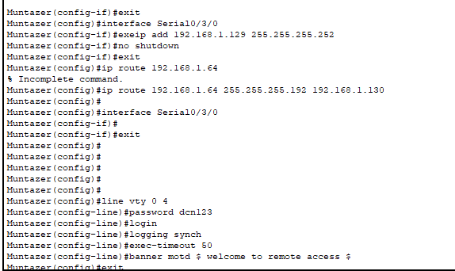

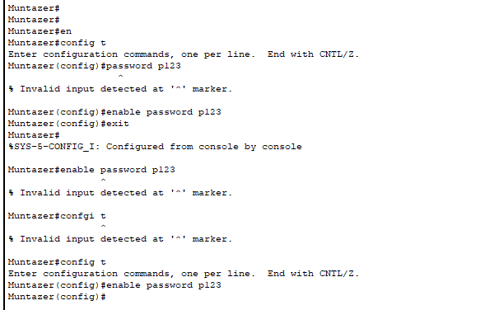

**Pc1:**

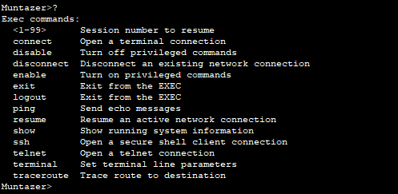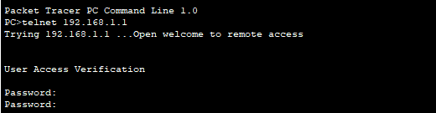

**Router 2:**

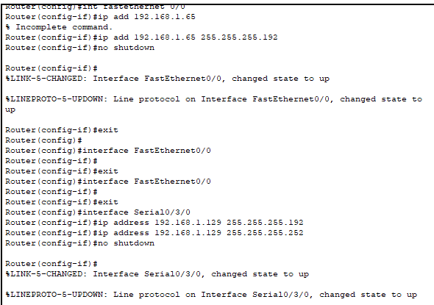

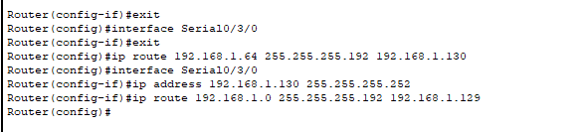

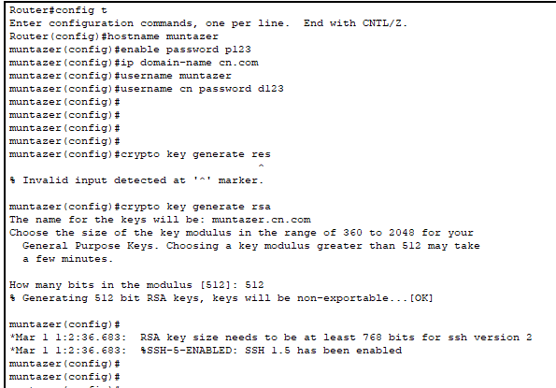

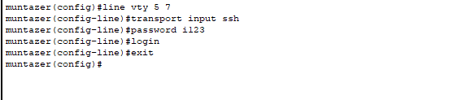

**PC2:**

